Spinach Madeline
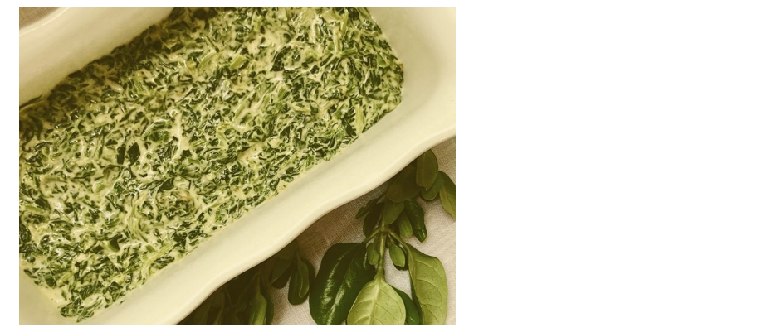Ingredients:
- 2 (10 ounce) packages frozen chopped Spinach
- ½ cup Water
- ¼ cup Butter
- 2 tblsp all-purpose Flour
- 2 tblsp minced Onion
- ½ cup Evaporated Milk
- 6 oz Velveeta Cheese with Jalapeno, diced
- ¾ tsp Celery salt
- ¾ tsp Garlic salt
- 1 tsp Worcestershire Sauce
- ½ tsp Black Pepper
- ¼ tsp Cayenne Pepper, or to taste
- Salt to taste
Directions:
- Place frozen Spinach and water in a saucepan over high heat; bring to a full boil
Reduce heat to medium, cover, and cook for 8 minutes
Cook for 2 more minutes then drain, reserving ½ cup of the reserved Cooking Liquid
- Melt Butter in a saucepan over low heat. Add Flour, stirring until blended and smooth, but not brown, 1 to 2 minutes
Add Onion and cook until soft but not brown, 5 to 7 minutes
- Slowly add Evaporated Milk and the reserved Cooking Liquid, stirring constantly to avoid lumps
Cook, stirring constantly, until smooth and thick, 3 to 5 minutes. Add Velveeta Cheese, Celery salt, Garlic salt, Pepper, Cayenne, and Salt; cook and stir until melted, about 2 to 3 minutes
- Stir in cooked spinach and serve immediately
Bon Appétit

